**Sally​​​ V/S Cloth**

**THE FIGHT**

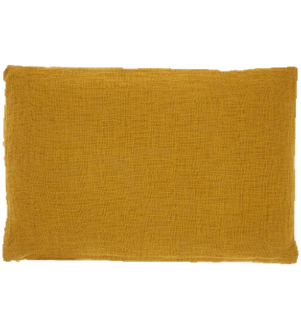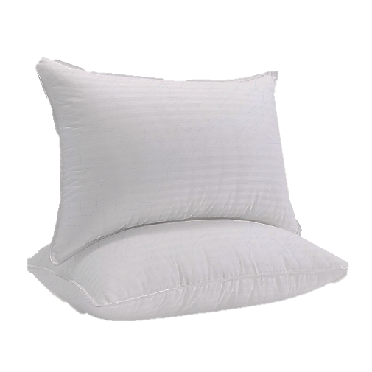

KHLORP VAEK - CLASS “ C”



-MY BUYER GUIDE ON PILLOWS -

**TABLE OF CONTENT**

[1. -Presentation of the products 3](#_Toc135300821)

[1.1 The cotton pillows 3](#_Toc135300822)

[1.2 ​ The cotton cloth 3](#_Toc135300823)

[2. Which pillow should I buy? 4](#_Toc135300824)

[3. Let's talk to the seller 5](#_Toc135300825)



-PAGE 1-

# C:\Users\khlorp.veak\Downloads\3289566_assistant_educator_professor_showing_teacher_icon.png-Presentation of the products

# 1.1 The sally pillows

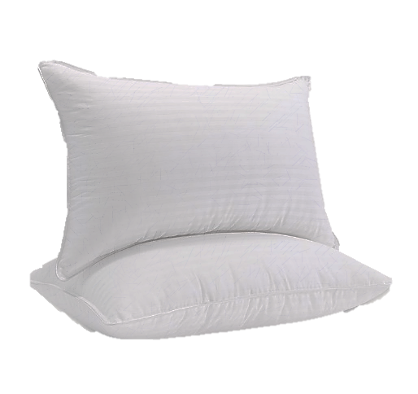Cotton sally are easy to sleep in, make us feel comfortable in a dream, calm and do not think about anything. In addition, it is effective in relieving insomnia when not having a headache. Its special feature is that it is "very soft"

## **1.2 ​ The cloth pillows**

****

Fabric pillows are made of pure fabric by the inside of the fabric. This pillow is heavy and durable. Its size is large and thick.this pillow is then made of hand-woven fabric.

-PAGE 2-

1 – The story of the cotton – 2023 – VEAK K

2 – Why it is so good - 20023 – VEAK K

# C:\Users\khlorp.veak\Downloads\3289566_assistant_educator_professor_showing_teacher_icon.pngWhich pillow should I buy?

- MY BUYER GUIDE ON GUITARS -

Cotton pillows are easier to sleep on because they are softer and easier to sleep in. An important aspect that makes this pillow attractive is that it is small so it makes our sleep better. It's cheaper than fabric pillows

|  |  |  |
| --- | --- | --- |
| leader, leading, president, speaking, speech | sally pillows | Fabric pillow |
| Soft meat | C:\Users\khlorp.veak\Downloads\done_all_FILL0_wght400_GRAD0_opsz48.png | C:\Users\khlorp.veak\Downloads\close_FILL0_wght400_GRAD0_opsz48.png |
| Sleep everywhere | C:\Users\khlorp.veak\Downloads\done_all_FILL0_wght400_GRAD0_opsz48.png | C:\Users\khlorp.veak\Downloads\done_all_FILL0_wght400_GRAD0_opsz48.png |
| High cost | C:\Users\khlorp.veak\Downloads\close_FILL0_wght400_GRAD0_opsz48.png | C:\Users\khlorp.veak\Downloads\done_all_FILL0_wght400_GRAD0_opsz48.png |
| Price 10$ | C:\Users\khlorp.veak\Downloads\done_all_FILL0_wght400_GRAD0_opsz48.png | C:\Users\khlorp.veak\Downloads\close_FILL0_wght400_GRAD0_opsz48.png |
| Can hide money | C:\Users\khlorp.veak\Downloads\done_all_FILL0_wght400_GRAD0_opsz48.png | C:\Users\khlorp.veak\Downloads\done_all_FILL0_wght400_GRAD0_opsz48.png |
| Price 10$ | C:\Users\khlorp.veak\Downloads\close_FILL0_wght400_GRAD0_opsz48.png | C:\Users\khlorp.veak\Downloads\done_all_FILL0_wght400_GRAD0_opsz48.png |

- PAGE 3 -

# C:\Users\khlorp.veak\Downloads\3289566_assistant_educator_professor_showing_teacher_icon.pngLet's talk to the seller

**sally pillows are the best friend of my life**

****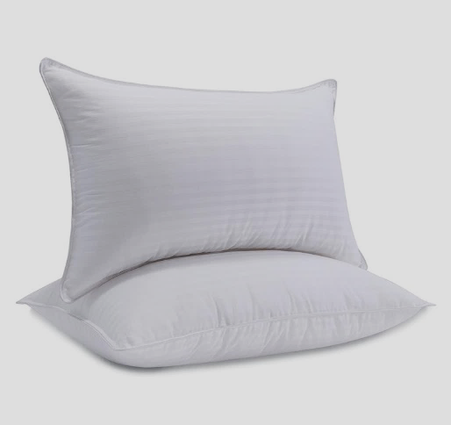

**V / S**

**Ctton pillows** **are the best friend of my life**



Why do you like Ctton pillows?

I like fabric pillows because they are hard and easy for me to sleep on. Cheap, easy, save money.

Choose​ the fabric pillows. Because he because he thought it was easy to sleep and it was soft.

- PAGE 3 -

Why do you like fabric pillows?